



# POWER CONSUMPTION ANALYSIS USING MACHINE LEARNING

SmartInternz

www.smartinternz.com

## Power Consumption Analysis Using Machine Learning

We are developing an advanced energy analytics platform designed to transform household power consumption data into actionable efficiency insights. By integrating high-resolution smart meter data, hyperlocal weather patterns, and appliance-level monitoring, our system creates detailed energy profiles for each household. Sophisticated machine learning algorithms analyze these datasets to detect inefficiencies—such as standby power drains, HVAC overuse during extreme temperatures, and underperforming appliances—while identifying optimal opportunities for load shifting and cost reduction.

The platform delivers personalized, context-aware recommendations tailored to each household’s unique usage patterns and regional utility rates. For example, it may suggest pre-cooling a home before peak pricing periods, automating high-energy tasks during off-peak hours, or upgrading specific appliances based on their actual consumption impact. Real-time savings simulations and intuitive dashboards empower users to make informed decisions, balancing comfort and cost. Additionally, the system can integrate with utility rebate programs, proactively notifying users of eligible incentives for energy-efficient upgrades.

By bridging the gap between raw consumption data and practical energy management, our solution enables households to reduce costs, minimize waste, and adopt more sustainable usage habits—turning everyday consumers into proactive energy optimizers.

**Technical Architecture:**

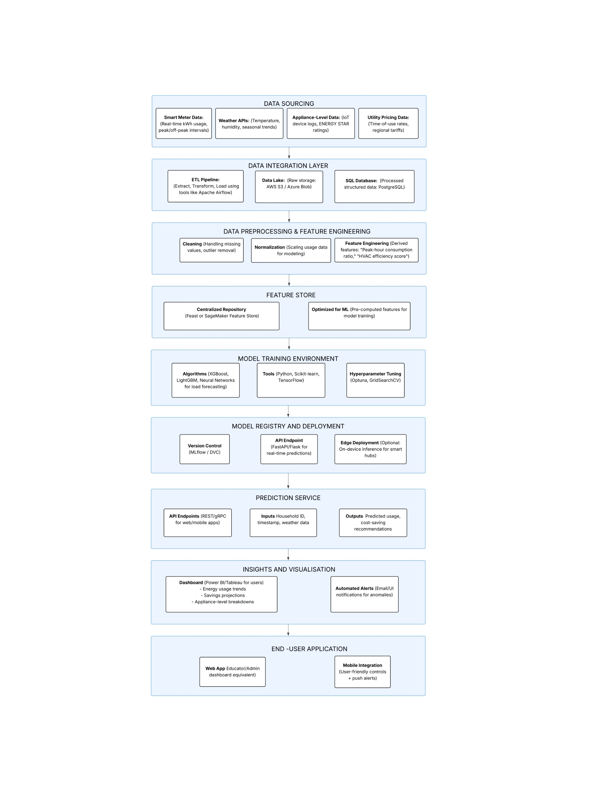

**Project Flow:**

1. **User Interface Interaction**: The system enables users to input data seamlessly through an intuitive User Interface (UI).
2. **Integrated Model Analysis**: The entered data is processed in real-time by a machine learning model for analysis.
3. **Prediction Display**: The model's predictions are instantly relayed back to the user through the UI, ensuring a responsive and efficient experience.

**Project Progress Summary:**

1. Problem Definition & Understanding

- Clearly defined the business problem and established project objectives.

2. Data Collection & Preparation

- Successfully gathered the required dataset.

- Conducted thorough data cleaning and preprocessing to ensure high-quality input for modeling.

3. Exploratory Data Analysis (EDA)

- Performed descriptive statistical analysis to understand data distributions.

- Created visualizations to uncover patterns, trends, and relationships within the data.

4. Model Building

- Trained multiple machine learning algorithms to develop a predictive model.

- Conducted preliminary testing to assess initial model performance.

5. Performance Testing & Hyperparameter Tuning**

- Evaluated model performance using various metrics.

- Optimized hyperparameters, resulting in measurable accuracy improvements.

6. Model Deployment

- Saved the best-performing model for production use.

- Integrated the model with a web framework to create a functional application for end-users.

This structured approach ensured a systematic progression from problem identification to a deployable solution.

**Project Structure:**

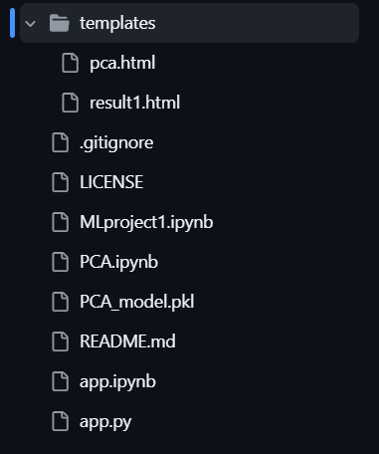

* We are building a flask application which needs HTML pages stored in the templates folder and a python script app.py for scripting.
* Dtc_model.pkl is our saved model. Further we will use this model for flask integration.
* Data Folder contains the Dataset used
* The Notebook file contains procedure for building the model.

### Milestone 1: Define Problem / Problem Understanding

**Activity 1: The business problem**

#### The project aims to analyze power consumption patterns in households to provide insights for energy efficiency and cost-saving measures. By analyzing historical power consumption data along with other relevant factors such as weather conditions, occupancy patterns, and appliance usage, the project seeks to identify trends and patterns that can help households optimize their energy usage.

#### Activity 2: Business requirements

#### The system must leverage current and relevant energy consumption data to provide reliable, real-time efficiency recommendations that reflect actual household usage patterns.

#### The solution should be scalable to accommodate data from diverse households and flexible enough to adapt to evolving energy usage trends, regional pricing changes, and new appliance technologies.

#### All energy usage data must be processed in compliance with privacy regulations (e.g., GDPR, local utility policies), ensuring sensitive household information is protected.

#### Outputs should provide clear, practical insights—such as cost-saving opportunities or inefficient appliances—enabling users to make informed decisions about energy usage and upgrades.

#### The platform must feature a user-friendly dashboard that visually presents predictions, savings estimates, and tailored recommendations for both technical and non-technical users.

#### The system should seamlessly integrate with smart home devices, utility APIs, and rebate programs to automate energy-saving actions and provide incentive alerts.

#### Users should be able to track the impact of implemented recommendations through measurable metrics (e.g., reduced kWh, cost savings) to validate system effectiveness.

#### Activity 3: Literature Survey

The transition toward sustainable energy consumption has made household energy efficiency a critical focus area for researchers, policymakers, and technology developers. A growing body of literature explores how data-driven approaches can optimize residential energy use, reduce costs, and minimize environmental impact. This survey synthesizes key research findings on the factors influencing energy consumption patterns, predictive modelling techniques for efficiency analysis, and the effectiveness of intervention strategies. By examining existing studies, we identify best practices, technological advancements, and unresolved challenges in the field—laying the groundwork for our project’s methodology and innovation.The growing emphasis on sustainability and smart grid technologies has accelerated research in household energy analytics, revealing several critical insights:

1. **Key Consumption Drivers**:  
   Studies indicate that household energy use is influenced by:
   * **Behavioral factors** (occupancy patterns, appliance usage habits)
   * **Physical determinants** (home size, insulation quality, appliance efficiency ratings)
   * **External variables** (weather conditions, time-of-use electricity pricing)
2. **Predictive Modeling Approaches**:  
   Machine learning techniques (e.g., regression models, neural networks) have proven effective in:
   * Disaggregating whole-home energy data to identify appliance-level usage (NILM techniques)
   * Forecasting peak demand periods based on historical patterns and weather correlations
   * Detecting anomalies indicative of inefficient equipment or energy waste
3. **Intervention Effectiveness**:  
   Research demonstrates that actionable feedback (e.g., real-time usage dashboards, personalized recommendations) can reduce consumption by 5-15%. The most impactful strategies include:
   * Shifting flexible loads to off-peak periods
   * Targeted upgrades to ENERGY STAR appliances
   * Behavioral nudges (e.g., thermostat adjustments)
4. **Implementation Challenges**:  
   Current limitations include data privacy concerns, model interpretability for end-users, and the need for hyper-localized weather integration to improve HVAC-related predictions.

**Activity 4: Social or Business Impact.**

### Social Impact:

### This project helps households save money by identifying energy waste and suggesting cost-cutting measures, especially aiding low-income families. It also promotes environmental sustainability by reducing carbon emissions and encourages energy-conscious habits through real-time usage insights.

### Business Impact:

### For energy providers, the analytics platform can improve demand forecasting and reduce grid strain, lowering operational costs. It also creates opportunities for new services, such as personalized efficiency plans or partnerships with smart home device manufacturers.

### Milestone 2: Data Collection & Preparation

#### Activity 1: Collect the dataset

Dataset Link: https://www.kaggle.com/uciml/electric-power-consumption-data-set

#### Activity 1.1: Importing the libraries

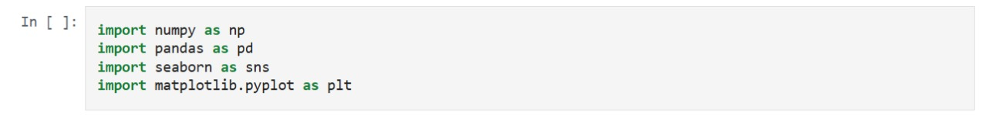

#### Activity 1.2: Read the Dataset

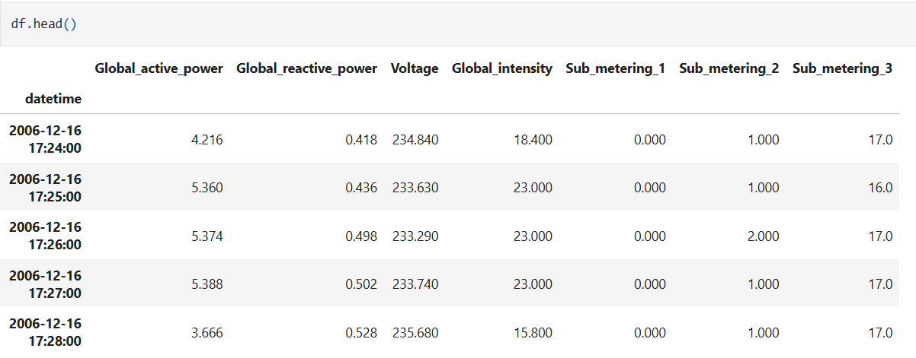

#### Activity 2: Data Preparation

#### Activity 2.1: Handling missing values

● For checking the null values, df.isna().any( ) function is used.

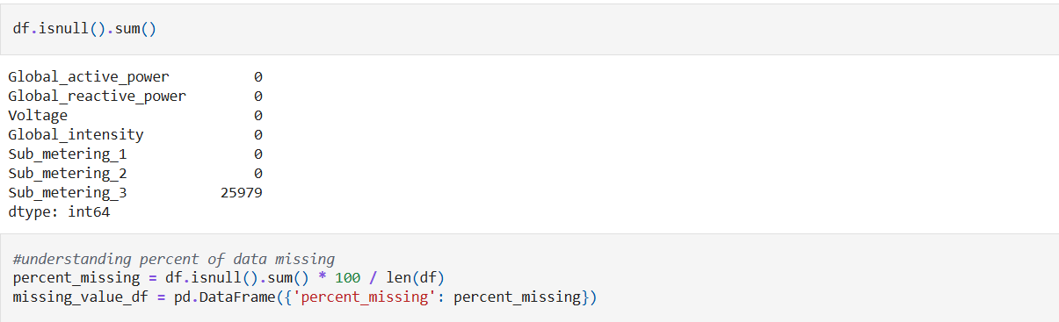

### Milestone 3: Exploratory Data Analysis

#### Activity 1: Visual analysis

Visual analysis is the process of using visual representations, such as charts, plots, and graphs, to explore and understand data. It is a way to quickly identify patterns, trends, and outliers in the data, which can help to gain insights and make informed decisions.

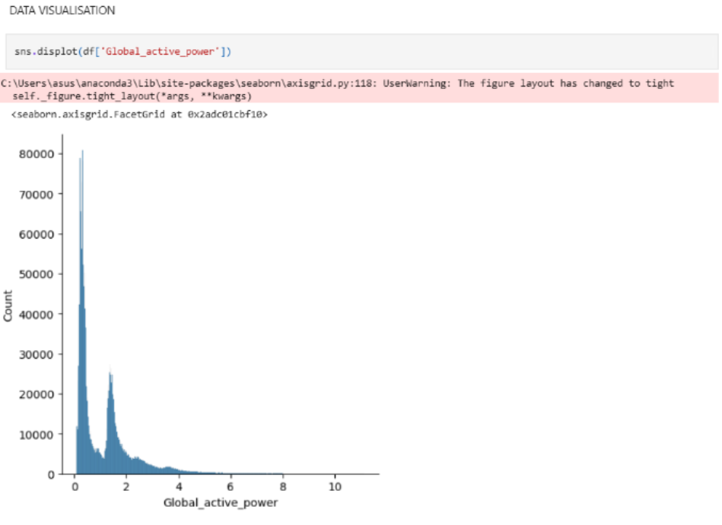

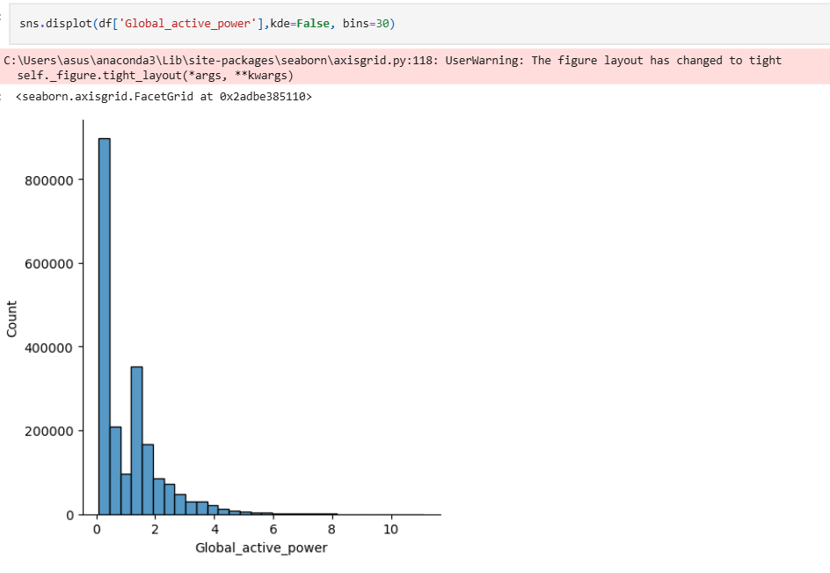

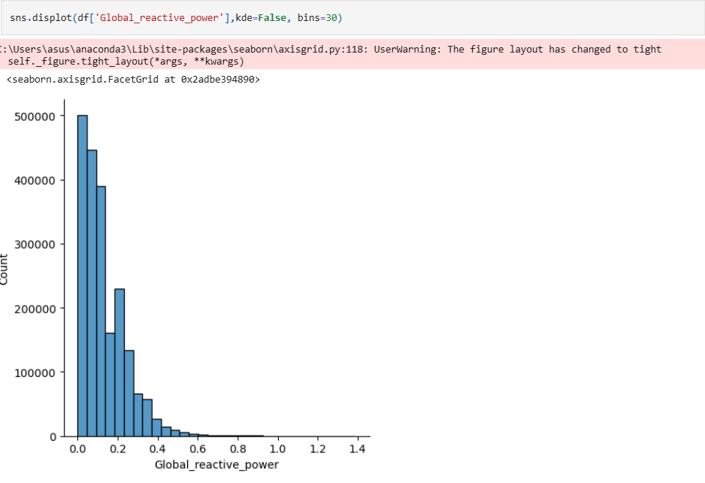

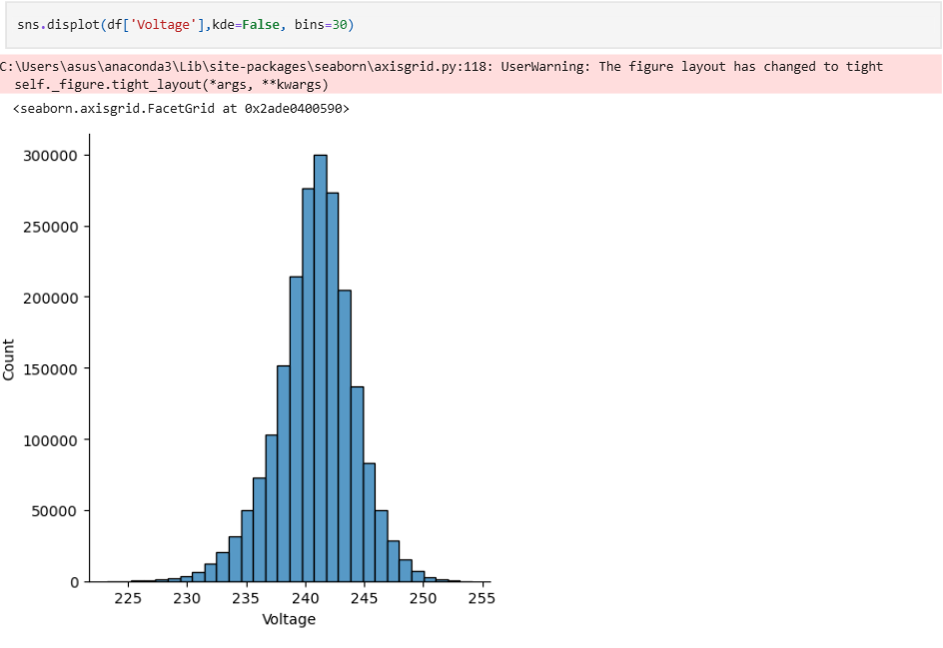

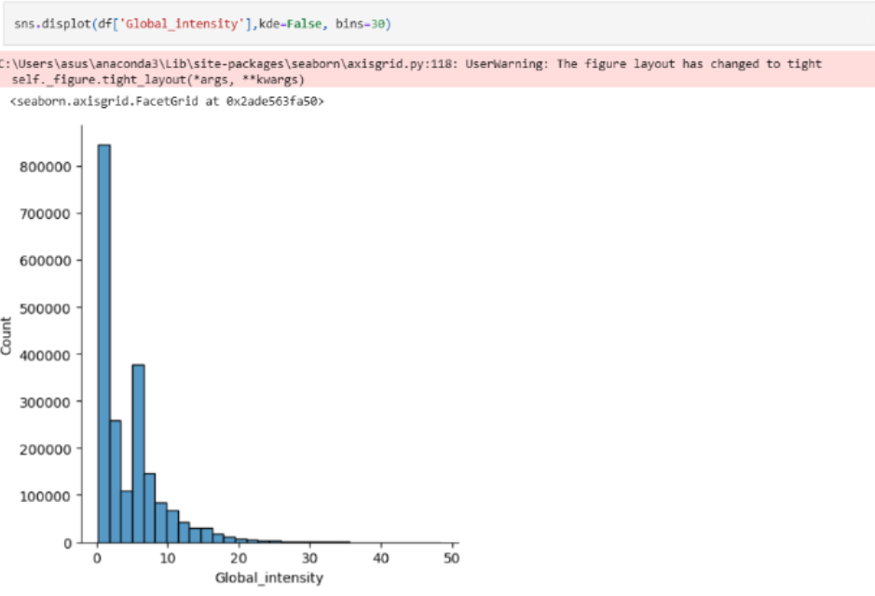

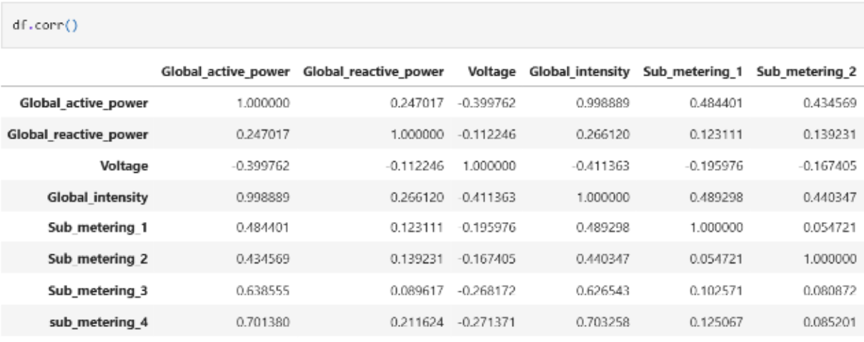

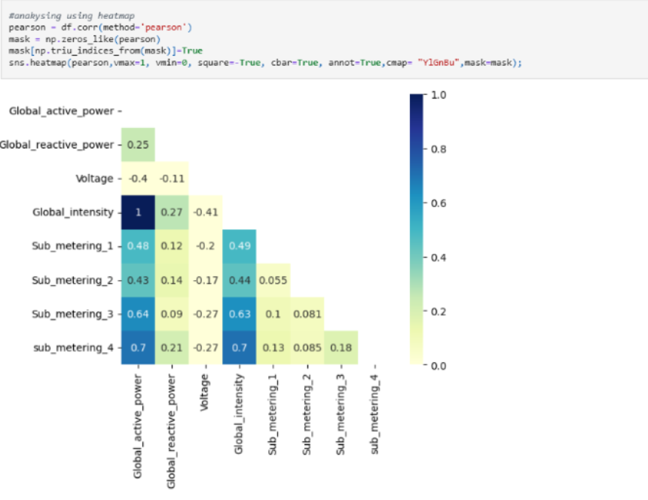

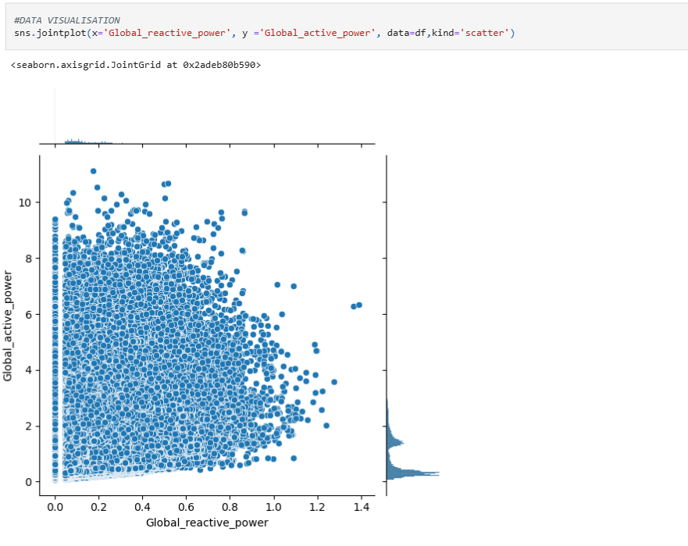

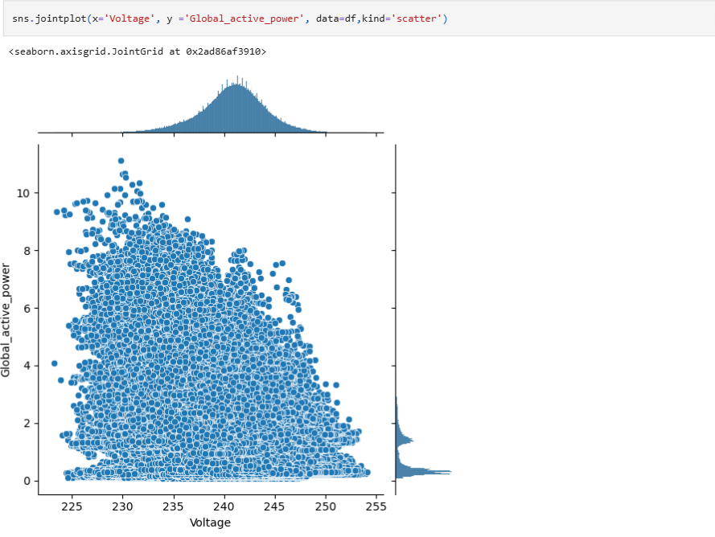

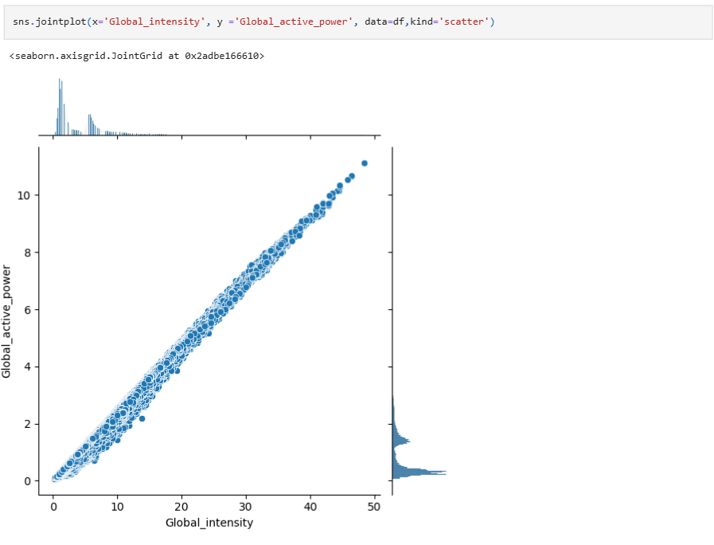

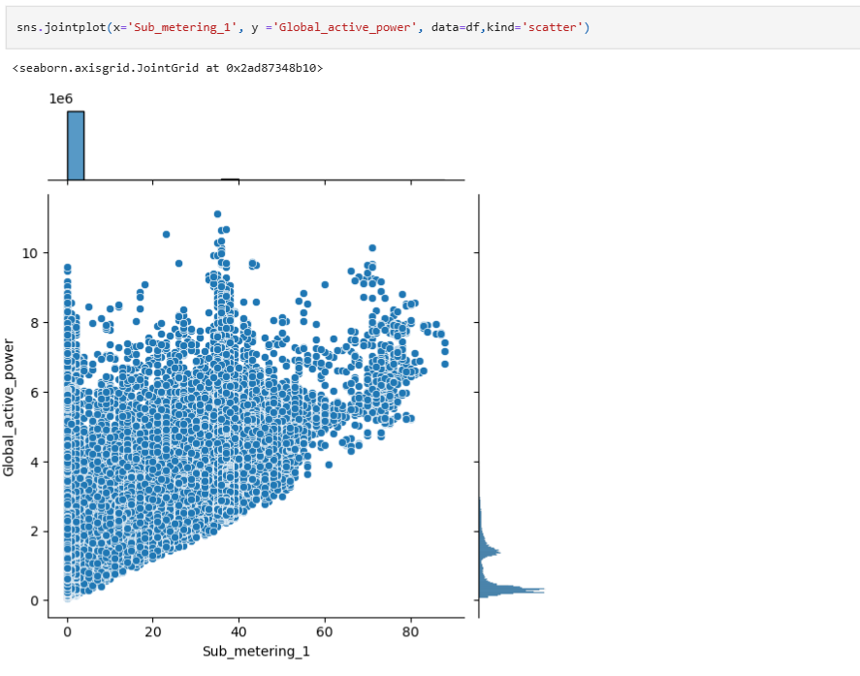

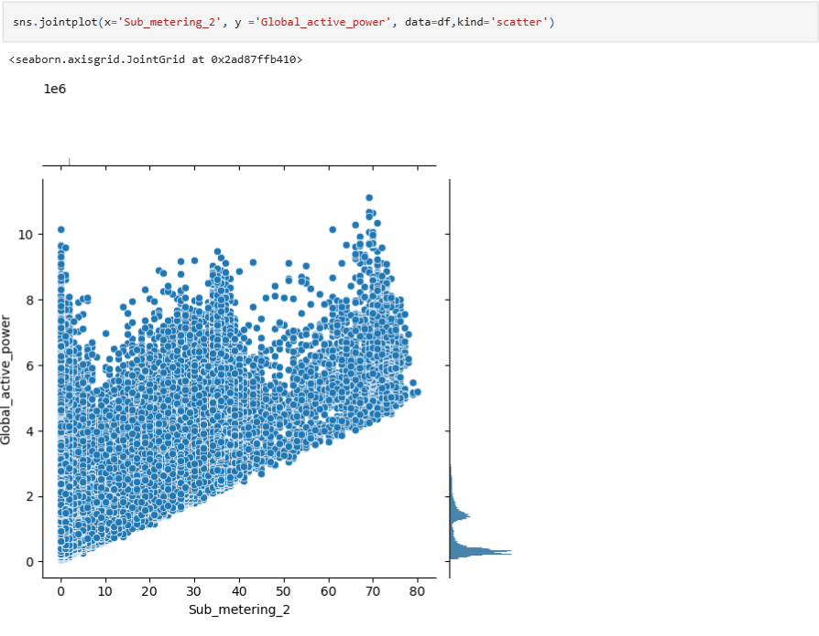

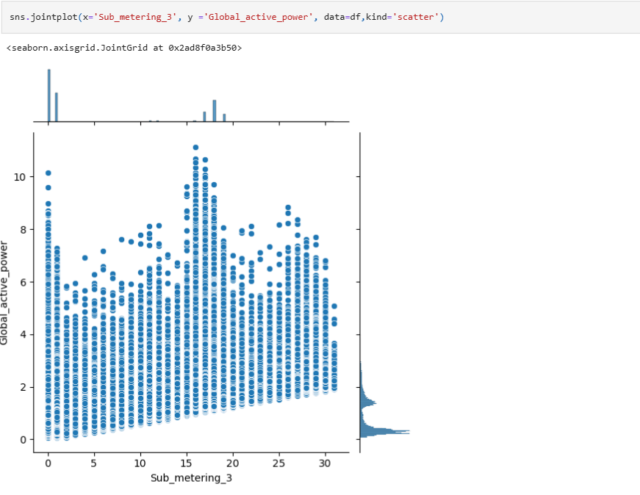

**Splitting data into train and test**

Now let’s split the Dataset into train and test sets. First split the dataset into x and y and then split the data set

Here x and y variables are created. On x variable, df is passed with dropping the target variable. And on y target variable is passed. For splitting training and testing data we are using train_test_split() function from sklearn. As parameters, we are passing x, y, test_size, random_state.

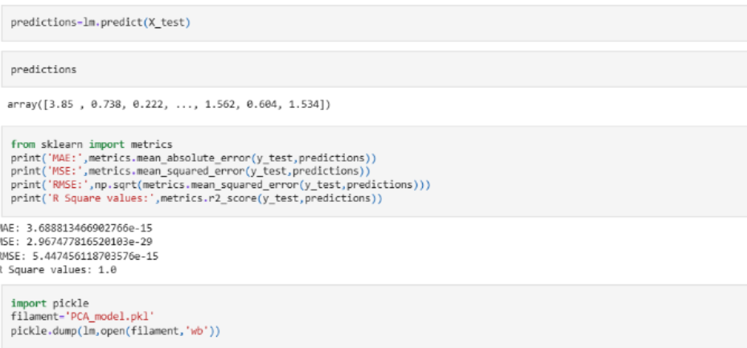

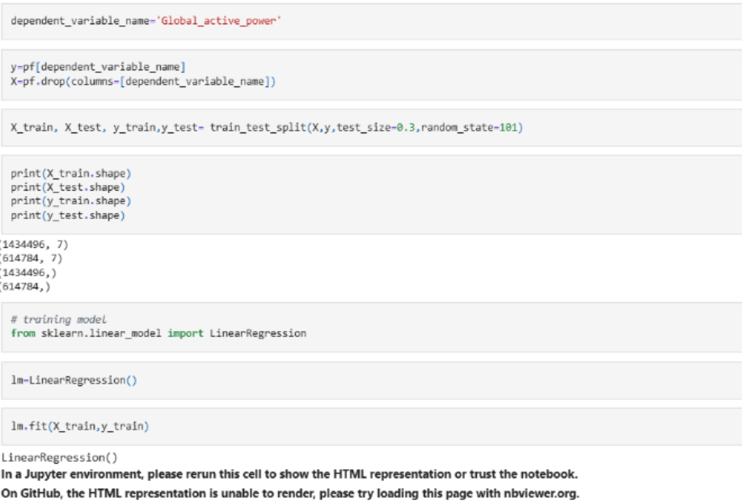

### Milestone 4: Model Building

#### Activity 1: Training the model

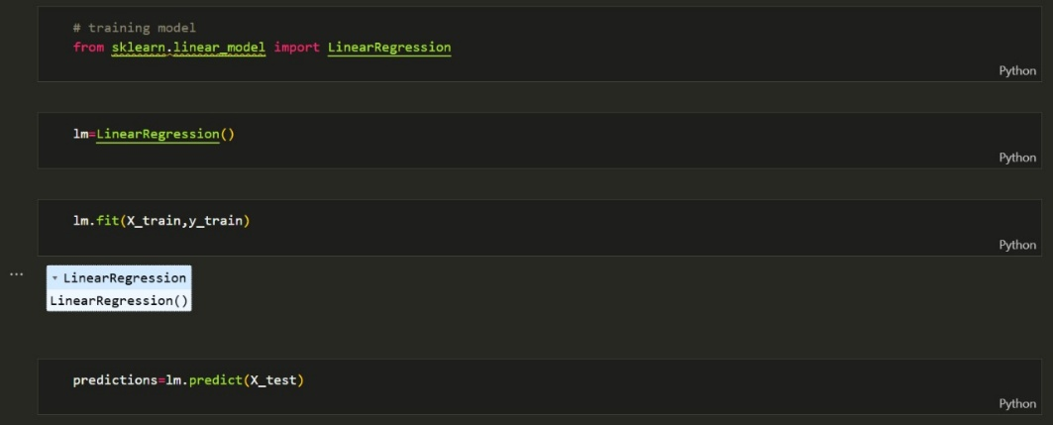

#### Activity 2: Testing the model

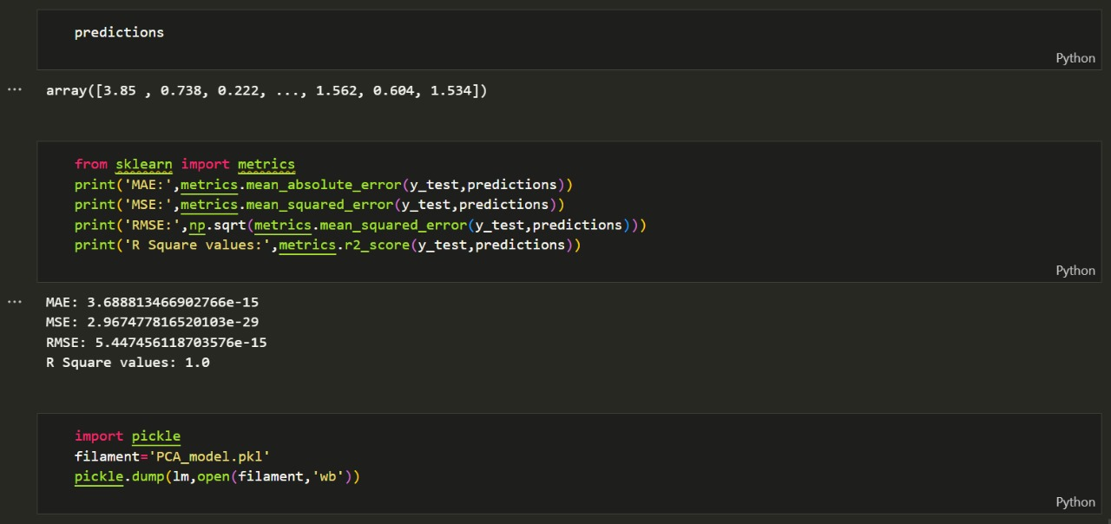

### Milestone 5: Model Deployment

#### Activity 1: Save the best model

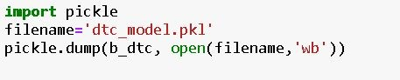

#### Activity 2: Integrate with Web Framework

In this section, we will be building a web application that is integrated to the model we built. A UI is provided for the uses where he has to enter the values for predictions. The enter values are given to the saved model and prediction is showcased on the UI.

**Activity 2.1: Building Html Page:**

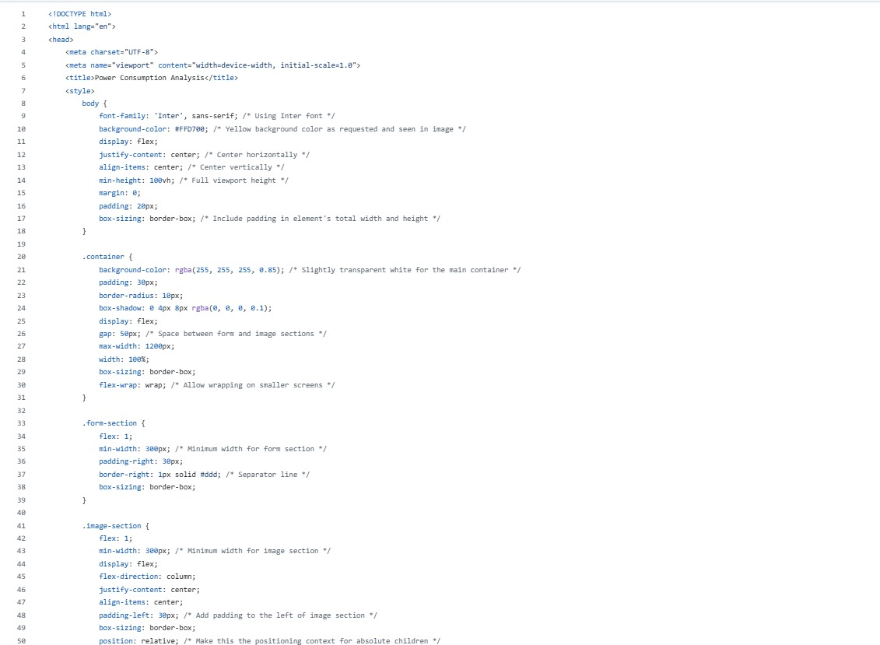

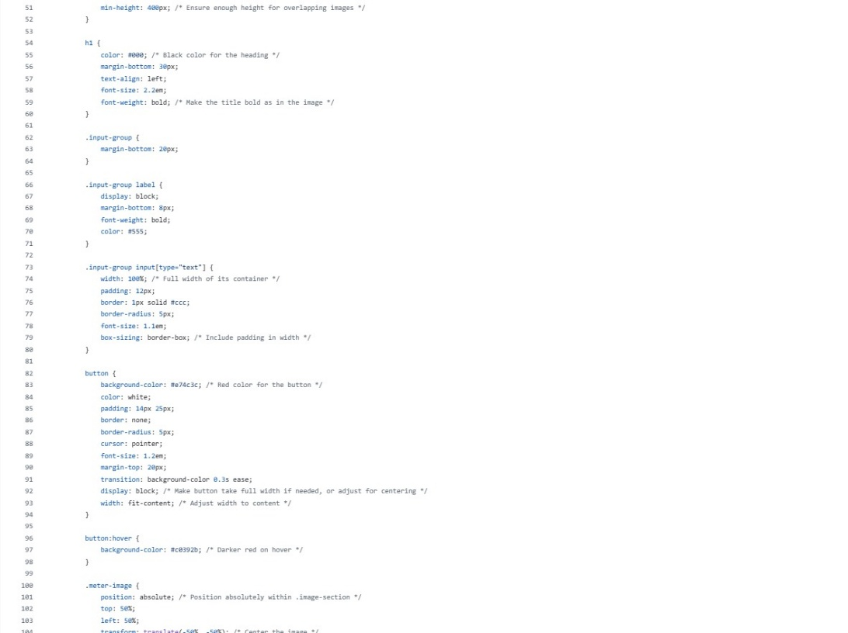

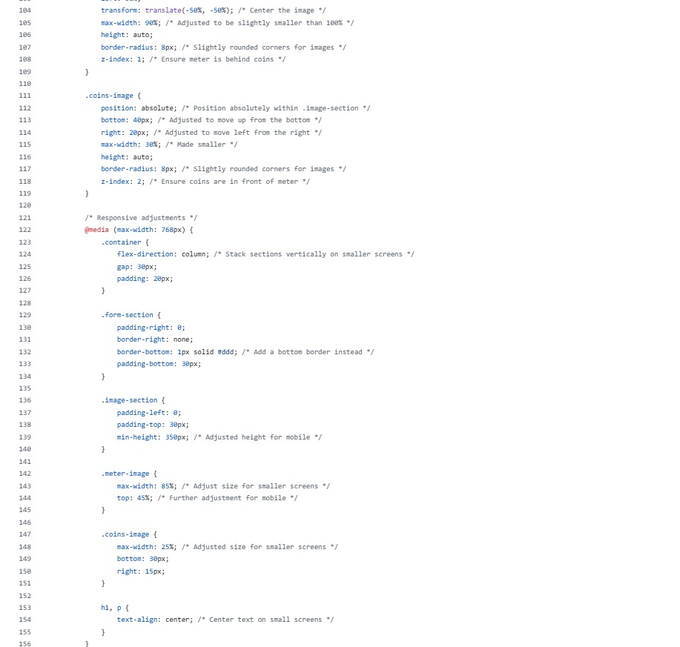

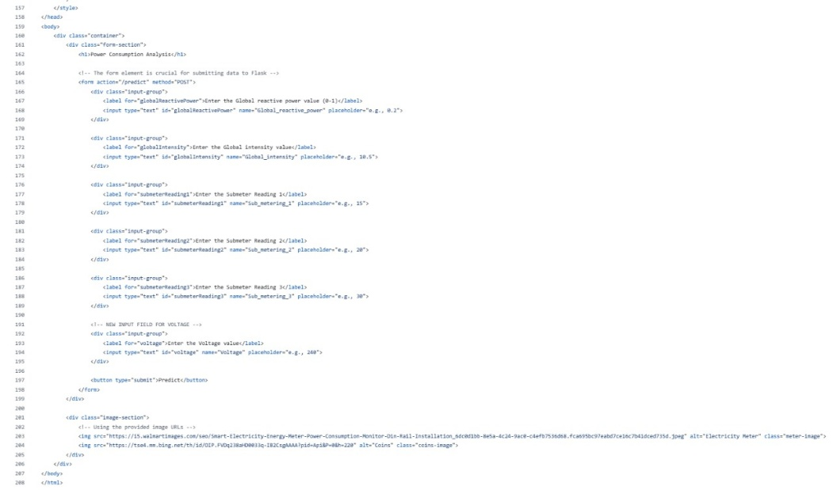

**Activity 2.2: Build Python code:**

Import the libraries

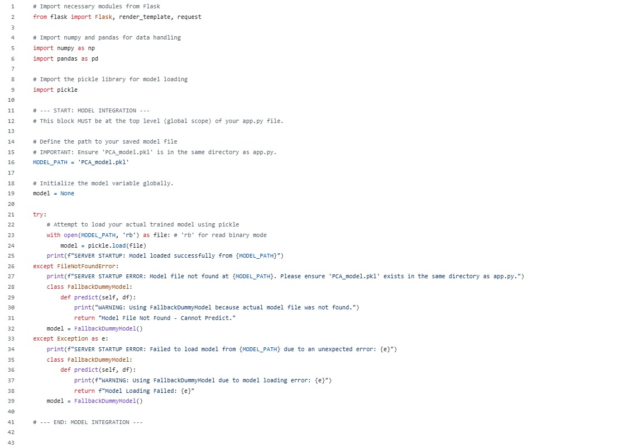

#### Activity 2.3: Run the web application

